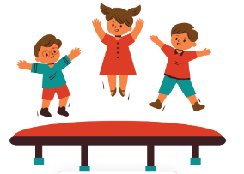
Dear Families,
The ability to focus and attend to lessons, directions, and conversations are fundamental skills critical to success in academics and our personal lives. Children learn as they watch adults, engage with peers, and are taught through formal and natural experiences. Play is natural for children, so why not build these skills through fun games that the whole family can enjoy? Here is a host of fantastic games you can play with your child to build these skills while spending time together. The games are appropriate for all ages.
General Following Directions Activities
1. Red Light - Green Light
- An adult is the “traffic light” and stands at the opposite end of the room or field from the child. The goal is for the child to make it to the opposite side while following directions.
- Hold up different colors to represent stop and go. Start with known cues of red and green. Then try different colors, such as purple for “go” and orange for “stop.” Try the opposite (red means go) or switch to using shapes or sounds to represent the actions.
- When someone “goes” when they should stop, simply have them return to the starting line.
- Give children a turn being the traffic light.
2. Conducting an Orchestra.
- Every child uses a musical instrument (real or improvised), and the “orchestra leader” uses a conducting baton. When the baton is up and waving, the children play their instruments. When the conductor puts the baton down, the children stop.
- Increase the complexity and attention required by having children play their instruments quickly when the baton moves quickly and slowly when the baton moves slowly. Try the opposite cues too.
3. Drum Beats
- Use drum beats (real or improvised) to represent different actions that children can do while sitting (e.g., clapping or stomping to the beat) or while moving around the room (e.g., walking or dancing to the beat). For example, children walk quickly to fast drumming, slowly to slow drumming, and freeze when the drumming stops.
- Request children to respond to opposite cues (walk slowly to fast drum beats and quickly to slow drum beats). Or add in different actions with specific drum cues. For example, slow drumming means stomping feet, and fast drumming means jumping jacks. Bonus: Try combining “Conducting an Orchestra” and “Drum Beats” into one game
4. Melting Snowman
- The Melting Snowman game focuses on children’s self-awareness. Start by asking the children to stand tall like a snowman.
- Children then relax or tense their bodies based on the adult's cues. When the sun is coming out, children relax or begin to melt. When the snow clouds roll back in, and it gets cold, children tense or freeze. This a great opportunity to build vocabulary with imagery and words such as “thaw, frost, evaporate, or steam:

5. Go & Grab
- This game supports memory and attention to detail. Instruct your child to go and get an item in the room and bring it to you.
- Build in the challenge by adding additional items, silly movements, more specific items (tall green glass), sending your child a greater distance, and adding tasks to do with the item once they bring it. Try giving all directions at once for a child to remember
- Example:
Level 1: go & grab the remote
Level 2: go & grab the remote and green dog toy
Level 3: go to the kitchen & grab a tall, red cup and place it upside down next to me.
Level 4: go to the kitchen & grab a tall, red cup and place it upside down next to me and roar like a lion!
- Give your child the opportunity to give the directions too. They’ll need to remember their directions to verify the adult or sibling followed through will all directions!

Math Activity
6. Go & Grab- Math Version
- All the same rules as the original, but add quantities for the child to get, e.g., go and grab 2 remotes and 5 dominoes.
- Once all items have been collected, give an addition or subtraction equation using the items. e.g., How many objects are in all? or If you have 10 dominoes and take away 3, how many remain?
- Ask your child to explain or show how they answer. For older students, you can use multiplication and division.
- Switch roles and have the child create the equation for the adult to solve. The adult should also explain their strategy to demonstrate multiple approaches to the child.

Reading Activity
7. Picture Search- An Adapted Kennedy Center CETA strategy
- Select a detailed or not-so-detailed image from a children’s book. It should be a story the child does not know. Have them study the one image and pull as many details as they can using the phrase:
“ I see_____” or, “ I notice ______.”
- Once every detail has been identified (or a sufficient number), follow up with the phrase:
“ When I see _____, I think ______” or “When I see ______, it makes me wonder ________”
- Read the story with the child to see how it compares to the inferences and predictions made.

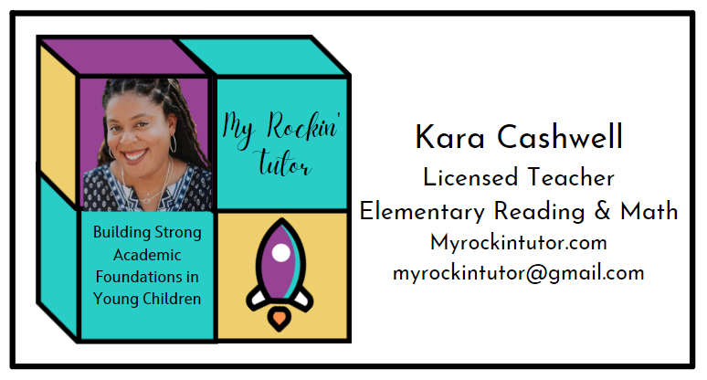
For More Games or to Learn more about Virtual Tutoring, visit
MyRockinTutor.com

